HTML/CSS Day 5 Knowledge Test

  - What tag is used for external links? (write out the complete tag with any attributes)
<link src= https://www.bbc.co.uk /> right answer - <a href=”…”> </a>
  - What tag creates list with a predefined style of bullet points?
<ul> </ul> - unordered list
  - Write out the main HTML tags that make up the skeleton of every website.
<!doctype html>
<html>
<head>
<title> </title>
<meta charset= “utf-8” />
<meta name= “viewport” content = “width=device-width, initial scale= “1” />
</head>
<body>
</body>
</html>

  - What is the purpose of the head tag?
To contain the information that is not physically seen on the page.

  - What area of the HTML page should you link in your CSS?
<head> </head>
  - How are websites made responsive?
Using media queries.
  - What is the selector used in CSS to embed/declare custom fonts?
@font-face
  - What is the purpose of a webkit?
To make sure that all browsers will support the css as some web browsers do not support all css styling.
  - Name all the webkit variations and the browsers that they support.
-webkit- chrome & safari
-moz- Mozilla
-ms- Microsoft

  - Name a benefit of using the Mobile first development approach?
Most people will use their mobile phones over a desktop when browsing so allows you to set out how the web page will look for the majority of people.
  - What part of the systems development lifecycle (SDLC) have we been practicing for most of this week?
Implementation
  - What is the next stage after the analysis stage in the SDLC?
Testing
  - What does HTML stand for?
Hyper text markup language
  - What does CSS stand for?
Cascading Style sheets
  - Write an example of a pseudo selector.
? answer = :before / :after/ :hover
  - Explain how the CSS position attributes relative and absolute can be used together.
You cannot use absolute without relative- Once you have made an attribute relative this means you can then use the absolute positioning to move elements around in relation to the relative attribute using top, left, bottom and right.
  - How can I access the li elements within CSS?

<nav>

<ul >
<li><a href="#home">Home</a></li>
<li><a href="#products">Products</a></li>
<li><a href="#products">Products</a></li>
</ul>
</nav>

Nav li a { }

Part 2

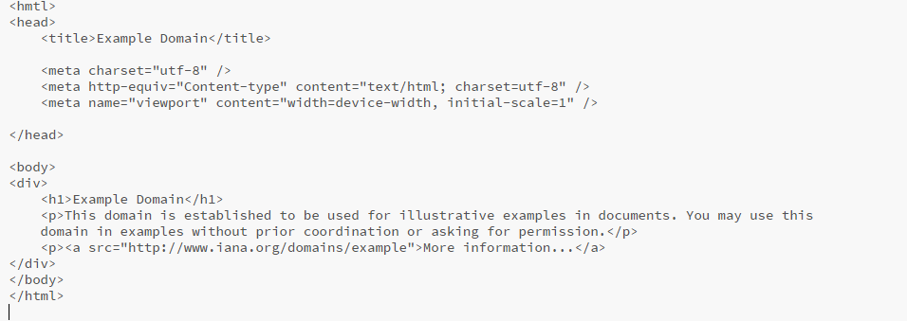
- Spot the errors in the following code.

There are approximately 3-4
- Missing doctype declaration
- Missing closing <p> in second paragraph.
- Missing href from <a> tag

- What 3 languages make up the web development trifecta?
Html, CSS & Java Script
- What tag ensures that text is displayed as bold/important in HTML?
<strong> </strong>
- Which of the following indicates an end tag?
/ * < @ “ !
/
- Write the required HTML code that would insert an image.
<img src= … /> don’t forget alt after image

Part 3

- How is a comment written in CSS?
/* ……… */
- What declaration allows you to change the color of the background?
background-color: black;

- Name a class selector and an ID selector.
.classSelector
#idSelector
- What is the default attribute for the position property?
? answer = static
- Write the following with the correct naming convention –

Class=” test class”

testClass

